|  |  |
| --- | --- |
| Close up of woman in classroom  RI Family Visiting Program TRAIN Manual | This manual is to help support the use of the Learning Management System (LMS), TRAIN. The LMS will house Professional Development opportunities to ensure a competent workforce.  Votta, Carol (RIDOH)  January 24, 2025, version 1.9.  <https://courses.ri.train.org/resources/RI%20FV%20TRAIN%20Manual.docx> |

Contents

TRAIN Account Creation………………………………………………………………………….……...2

How to Upload External Certificates………………………………………………….……...……7

RI Family Visiting Trainings and Recordings……...……………………………………..……..8

Courses with CMEs/CEUs…………………………………………………………..……………………9

Supervisors: Access Staff’s Accounts………………………………………………….……..….10

Calendar……………………………………………………………………………………………………….11

TRAIN Account Set Up Directions

1. User will receive an invitation to join TRAIN. The Rhode Island TRAIN portal can be accessed at <https://www.train.org/rhodeisland/welcome>
2. User will be asked to create an account-click “Create Account”

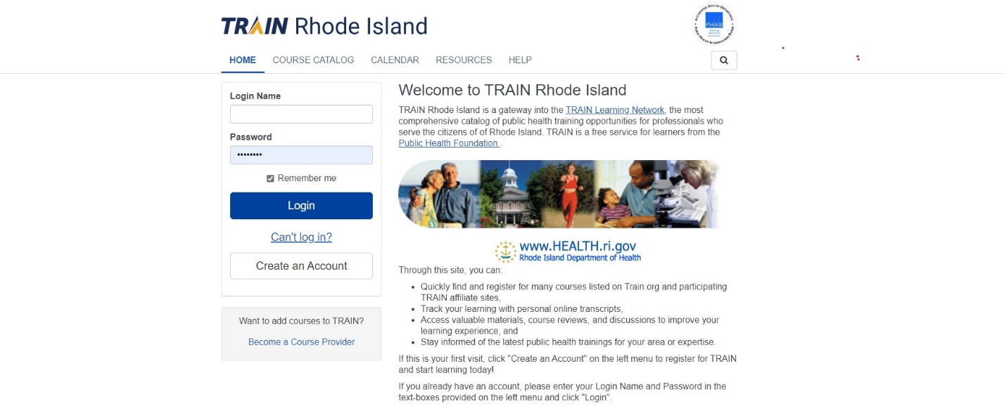

1. Create a Login Name and Password- The Login name should be professional and based on your name. For example, the last name and first initial may be used (DoeJ for John Doe). The Password must contain at least one lower case letter, one upper case letter, one number and have a total of at least eight characters.

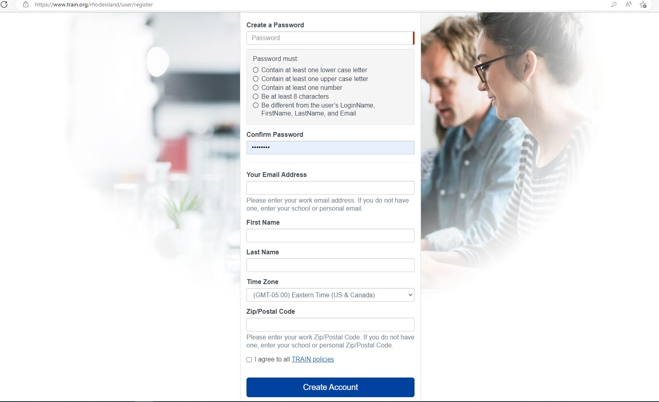

1. Add Email address, name, time zone (Eastern Time U.S. and Canada), zip code and make sure the TRAIN polices box is checked off once read, then click “Create Account”.
2. Navigate to “Your Profile” icon at the top right corner of the home page
3. Enter all the required information under each tab making a note of the following:
   1. “Manage Groups” tab use Join by Group Code field and enter “Rhode Island Family Visiting Program” and click join.

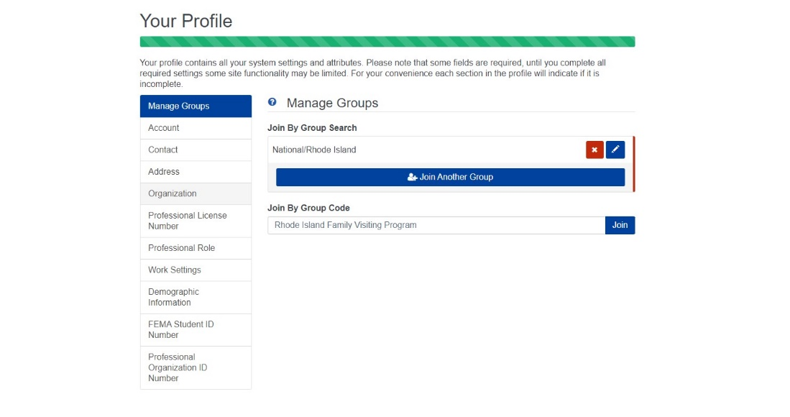

Once you enter the code you will see Family Visiting Program under Manage Groups

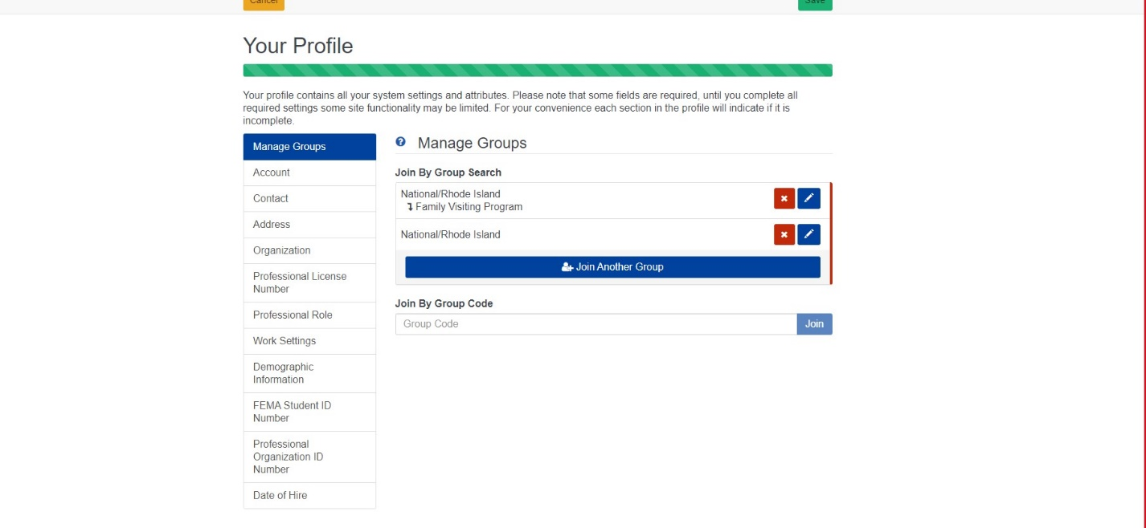

* 1. “Account” Fill in your Email address and mark “Yes” to both questions. It is imperative the user answers “Yes” to “I would like to allow TRAIN Rhode Island to send me notifications via email” to receive training announcements.

** **Please verify your e-mail, if user does not verify e-mail used for account creation, the question will default back to “No”. \*\***

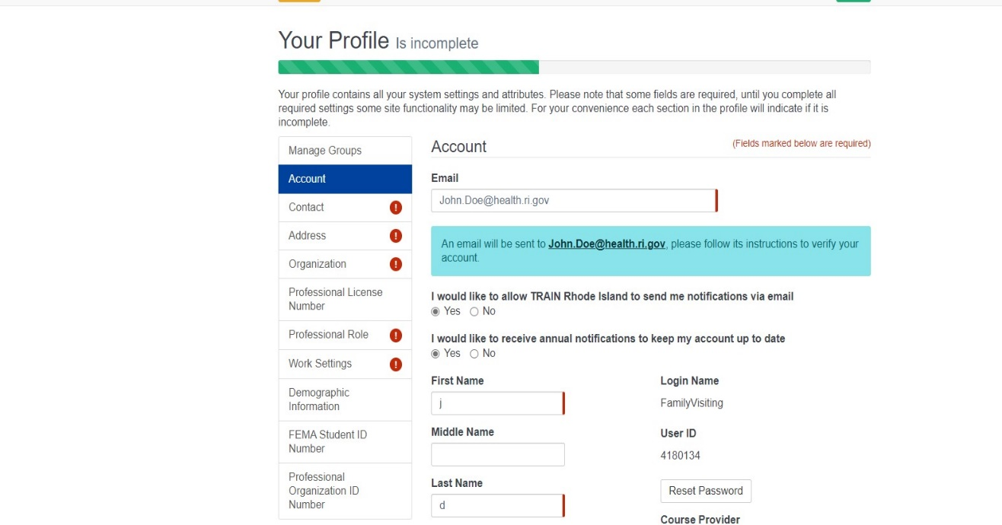

* 1. “Contact” tab- enter preferred phone number
  2. “Address” tab-please make sure Eastern Time is selected for “Time Zone” field and enter business address.
  3. “Organization” tab- under “Organization Name” please enter “Rhode Island Department of Health” **regardless of user’s affiliated agency/program. Side note**: The Family Visiting TRAIN group is under the Rhode Island Department of Health’s umbrella.
     1. “Department/Division field” enter user’s agency e.g., “BVCAP”,” BWRSD”, “CCA”, “CCF”, “CCAP”, “CF”, “EBCAP”, “FSRI”, “Meeting Street”, “VNS”, and “WSD”
     2. “Bureau/Section” enter program model: **Please only** use “FC”, “HFA”, “NFP”, “PAT”, “EI”, “EHS” “HS”, “PRS”, “WIC” or other please specify in this field for each program model.
     3. “Title” enter user’s role e.g., Supervisor, Parent Educator, Family Resource Specialist, Nurse

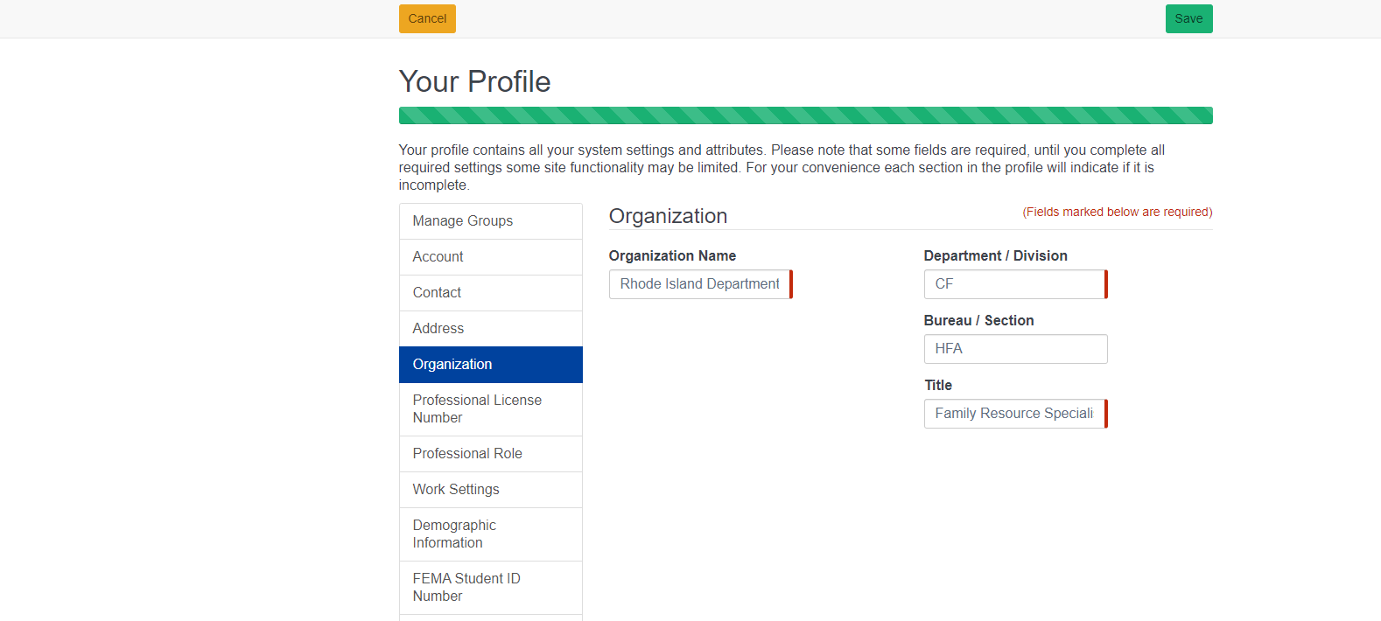

Role

Program

Agency

Agency

* 1. “Professional License Number” tab is not a required field, complete only if applicable
  2. “Professional Role” tab- check off “Family Visiting Staff” or “Peer Recovery Specialist” box which is halfway down page and other applicable roles i.e., Nurse
  3. “Work Settings” tab- please choose at least one applicable work setting
  4. “Demographic Information” tab- birthdate is not required but please complete all sections including languages spoken
  5. “FEMA Student ID” and “Professional Organization ID Number” tabs, do not need to be completed and can be left blank.
  6. “Family Visiting Information” tab- Please enter Certified Lactation Counselor Certification number and expiration date if applicable.

“Date of Hire”- please entire hire date and “Supervisor information”- please provide supervisor’s name and e-mail

Upload External Certificates

User can upload certificates of completion from external trainings (not sponsored by RIDOH). Log into TRAIN account and click on “Your Learning” then “Your Transcript”. User will click on button “Add an external record”. Record all the fields regarding the course. Click “Save” and then click “Cancel”. It will take the user back to “Your Learning” tab where the newly added external content will be found.

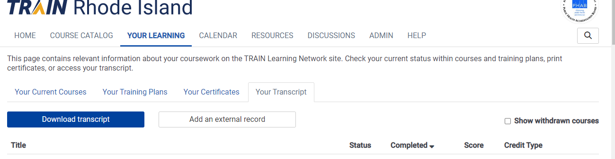

Click on the ellipsis (three dots to the right of the screen) and user will have the opportunity to upload a certificate.

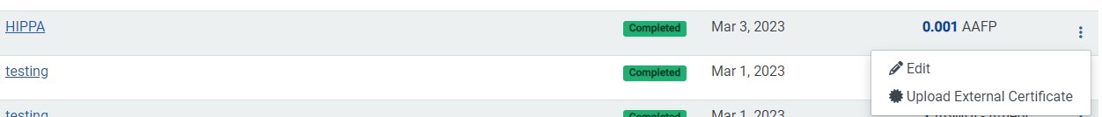

This certificate will now be part of the training record.

RI Family Visiting Trainings

<https://www.train.org/main/search?type=course&cp_organization_id=3482> in TRAIN to get to the page that lists all the RIDOH Family Visiting trainings.

Or you can manually filter by:

At the Home screen, tab to “Course Catalog”

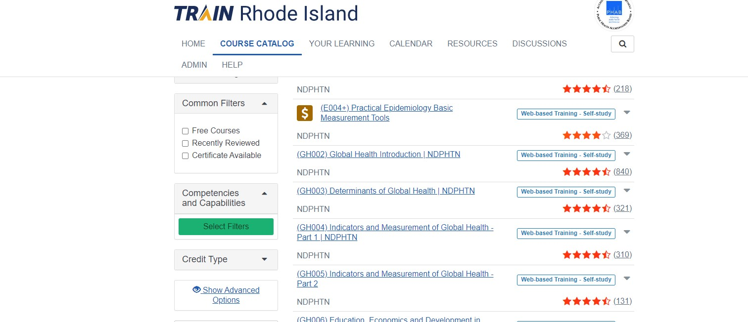

Click on “Show Advanced Options” and then click on “Organization” and enter “RIDOH FVP” (in drop down.) 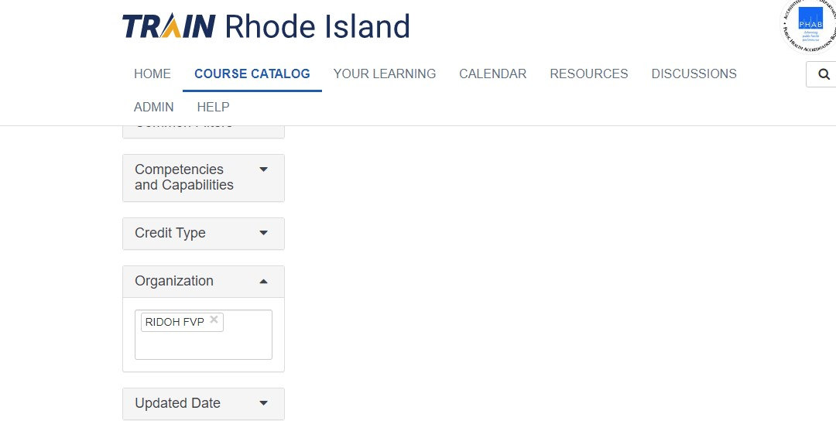

A list of RI Family Visiting trainings will appear but you will need to scroll up. Note once you register for a course you will receive confirmation and it will appear on your dashboard.

To access a **list of Family Visiting recordings** please log into TRAIN and then click on this link in a new tab:

<https://www.train.org/rhodeisland/search?type=course&cp_organization_id=3482&label_id=8>

A user can also filter by “Organization” see page 8 (RIDOH FVP) first and then “Format” tab (chose drop-down Webcast recorded) and this will take the user to the link of recordings.

Courses with CMEs/CEUs

Click on “Credit Type” and a drop-down box of all the courses available with credits attached.

**Make sure you remove the RIDOH FVP filter if checked in the Course Catalog tab,**

**so, your search goes beyond the Family Visiting Program. Refer to page 8 for how to filter for RIDOH FVP courses.**

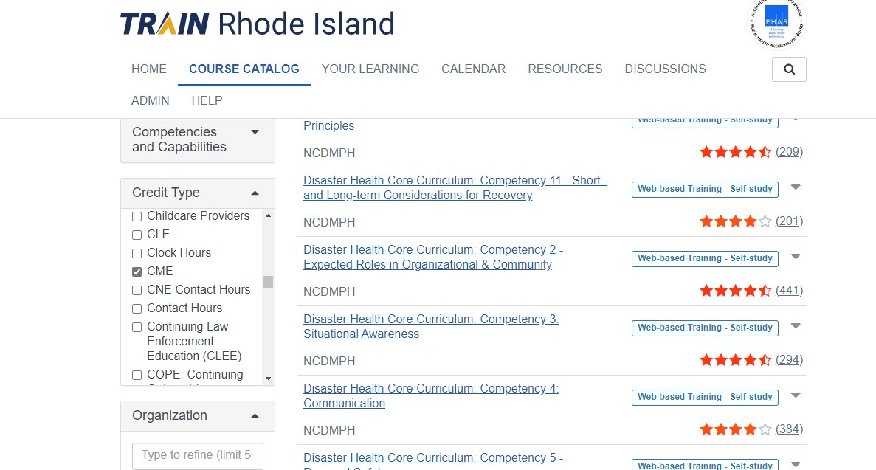

Supervisors: Access staff’s Accounts

1. Sign into your TRAIN account
2. Supervisors/Program Managers will have the “Admin” tab on the top of the screen.
3. Look for the “Users” tile (left hand side) and click on “Find and edit existing users”

1. A list of staff will populate; click on ellipsis next to name to view transcript, courses assigned and profile.

Calendar

A “Calendar” tab is available on the TRAIN dashboard that includes a filter. Click the check box for “Rhode Island events” and click “Apply”. This will now display RI trainings and can be viewed by month, week, or day.

For courses registered, the user will see an “R” in front of the training title. The user can click on the training they have registered for, and it will take the user to the course content. A legend is available at the bottom of the calendar.

